Neighborhood Handout (Working Draft)
Residential Curbside Electric Vehicle (EV) Charging Station

Date

Your neighbor at is applying to install an electric vehicle (EV)
Applicant’s address
charging station at the curb adjacent to their home. The charging station will allow your neighbor to charge their electric vehicle while it is parked on the street. The adjacent street parking will remain available to everyone. The charging station will belong to your neighbor and the [locality name here] will permit its installation near the curb. The permitting process requires that the charging station be safely installed and properly maintained.

What is an electric vehicle charging station and is it safe?
An electric vehicle charging station is a “box” and a special cable designed for safe transfer of electricity to an electric vehicle. The charging station contains special electronics that sense when the cable has been connected to an EV and only allows electricity to flow through the cable while connected to the vehicle. Most home charging stations provide “Level 2” charging at 240-volt AC power. Level 2 charging typically adds 10-15 miles of range to an EV per hour of charging.

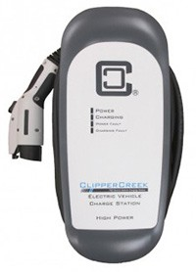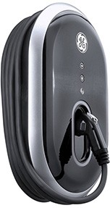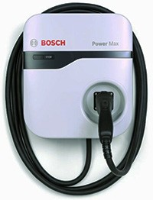
Figure 1Examples of electric vehicle charging stations, also known as electric vehicle supply equipment
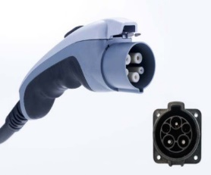
Figure 2 SAE J1772 electric vehicle connector (and inlet that would be present on an EV)
Figure 3 Examples of installed residential curbside electric vehicle charging stations. Photos courtesy of Sarah Moore, Berkeley Residential Curbside EV Charging Pilot Program.
Charging stations have built-in safety protections that are tested and certified to national codes and standards. They are safe to operate, even in wet weather. The special cable of the charging station has a standardized connector, known as SAE J1772, which can only be plugged into an electric vehicle. As a safety feature, no electricity can flow to the cable or connector unless it is properly plugged into an electric vehicle.
Does this mean that I won’t be able to park on the street near this charging station?
No. The charging station will belong to your neighbor for their personal use, but the street parking near the charging station will remain available to anyone. Any parking restrictions on your street, such as Residential Preferential Parking, will remain in effect. Your neighbor hopes to be able to park near the charging station in order to charge their electric vehicle on a regular basis, most likely overnight, but does not have any exclusive rights to the street parking. Streets are a shared, public resource.

Who is paying for this?
Your neighbor. The cost of purchasing, installing, using, and maintaining the electric vehicle charging station are all paid by your neighbor.

Why does my neighbor want to drive an electric vehicle?
Please ask your neighbor. Some of their reasons may include:
- Vehicle fueling and maintenance savings
- Federal incentives for the purchase/lease of EVs
- [Locality name and environmental goals here]
- Driving and safety benefits
- Environmental benefits
- Energy security

Why is the [locality name here] offering this Residential Curbside EV Charging Pilot?
The [locality name here] promotes the adoption of electric vehicles as one means of reaching our ambitious goal to reach net zero carbon by 2045. The [locality name here] is focused on efforts that make charging EVs in our community easier and more convenient. Only 40% of Virginians have access to electricity within 20 feet of where they park. Increasing the availability of curbside charging will extend EV charging access to those who lack garages, driveways, or off-street charging.

Who can I contact for more information, concerns, or questions?
You will have a formal period for comment on this project through a posted notice prior to the City permit being issued. In the meantime, your questions are welcomed by:

^{Applicant’s Name}  ^{Address}  ^{Phone}  ^{E-mail} | [Locality] Contact information here  Address  Phone Number  Email  Website

